Robotics
Milestone 3
Team 8

The Inverse Position Kinematics:

Using the Newton Raphson Method, this was the equation used:
$$q_{n+1}=q_{n}-{\left[\frac{∂F}{∂q}\right]}^{-1} F(q_{n})$$

end
The $q_{n}$ is the initial guess used which is a 4x1 matrix (4 DOF)
The inverse matrix is doing partial differentiation of the function with respect to q then getting its inverse.
The F($q_{n}$) is the last column of the transformation matrix X E.E, Y E.E and Z E.E (first 3 rows).
The equation is put in an iterations (loop) where the value obtained is put as the initial guess till the error is extremely small.

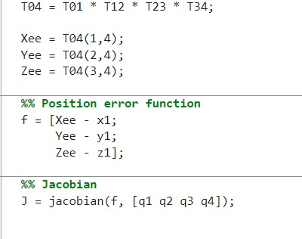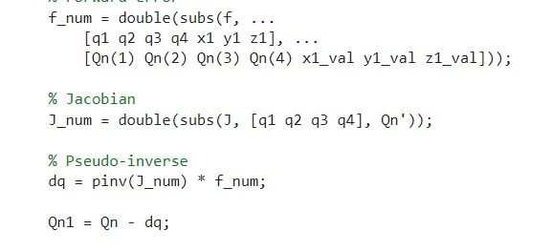

The first image showing the transformation matrix T4 wrt T0. F is the function qn and the J is the partial derivative matrix. The second image, f_num is the function qn after adding inputs. Pinv is the inverse of the J. Qn+1 is the first value for the first iteration.

The Forward Velocity Kinematics:

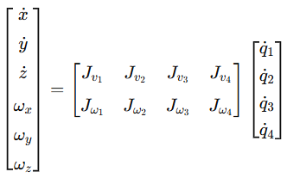

In Jacobian Matrix:
Each Row: presents the contribution of each joint in the calculation of a specific velocity component of the end-effector.
Each Column: present the contribution of a Specific Joint in all the velocity components of the end-effector.
- (Jvi) is a 3X1 vector describing the effect of the it Joint on the translational
velocity of the end-effector.
• (Jwi) is a 3X1 vector describing the effect of the ith Joint on the rotational velocity of the end-effector.

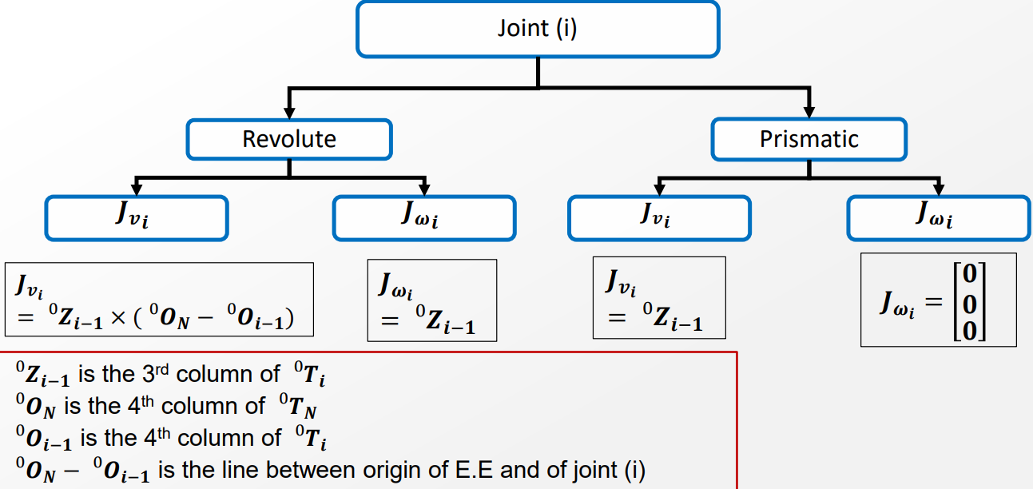

The Inverse Velocity Kinematics:

$$\dot{q}=J^{-1}\dot{X}$$
$\dot{q}$ is 4x1 matrix from $\dot{q_{1}}to \dot{q_{4}}$
$J^{-1}$ is over actuated so in order to get it, this was the equation used $J^{+}=J^{T}{\left(JJ^{T}\right)}^{-1}$ .
In matlab we used a predefined function (Pinv).
The $\dot{X}$ is the inputs used.

Finalized Hardware Fabrication:

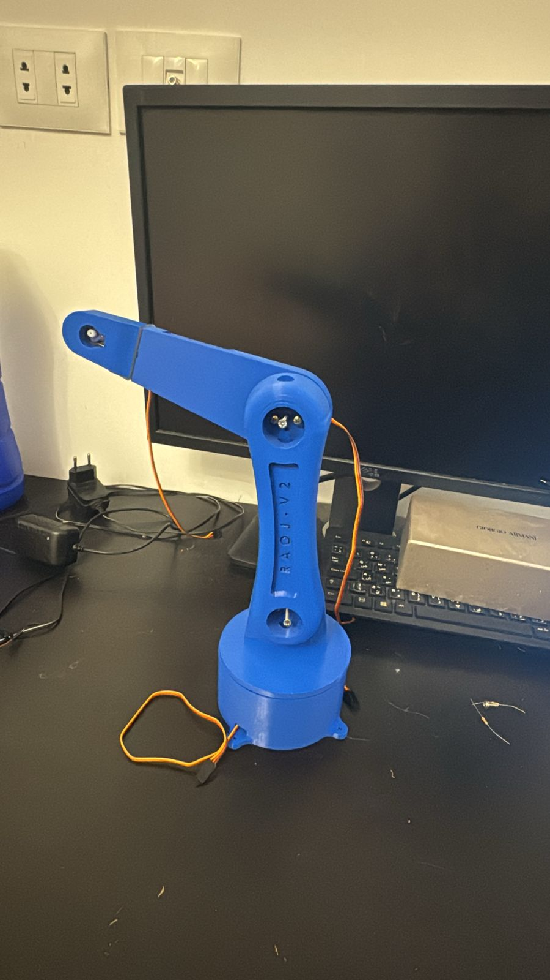

Finalized hardware fixations:

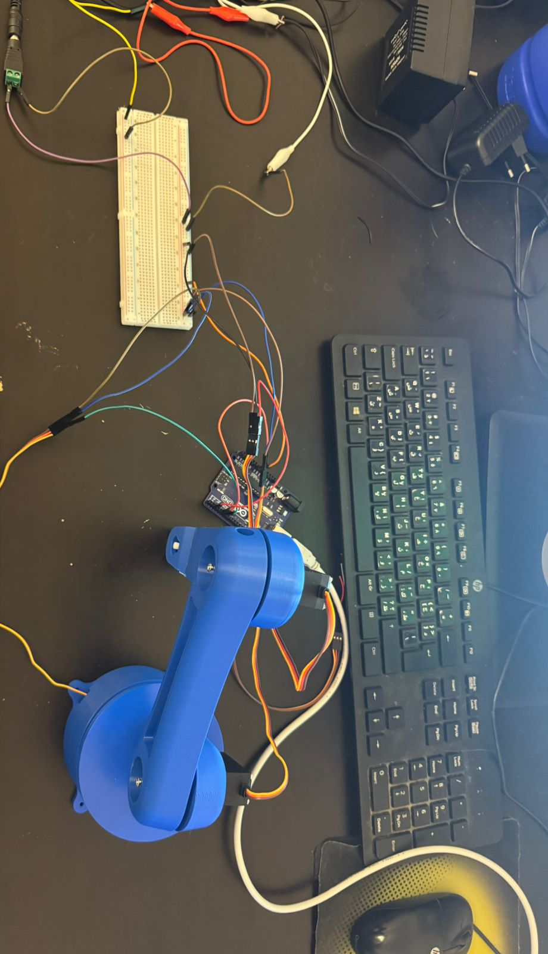

Hardware organized circuitry:
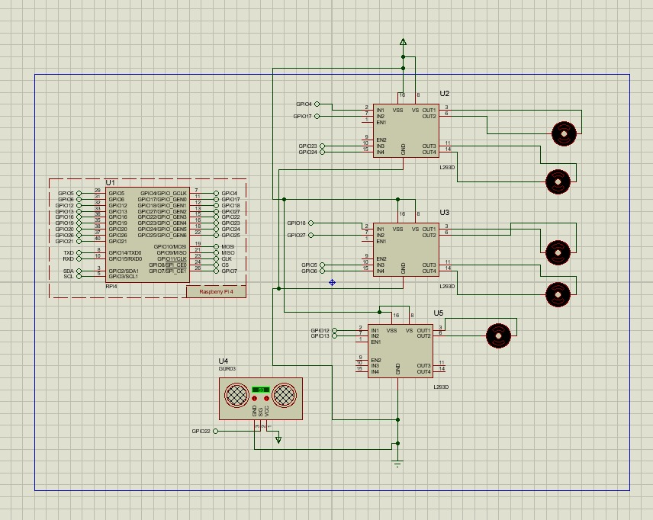

Simescap position resaults:

The desires Xs 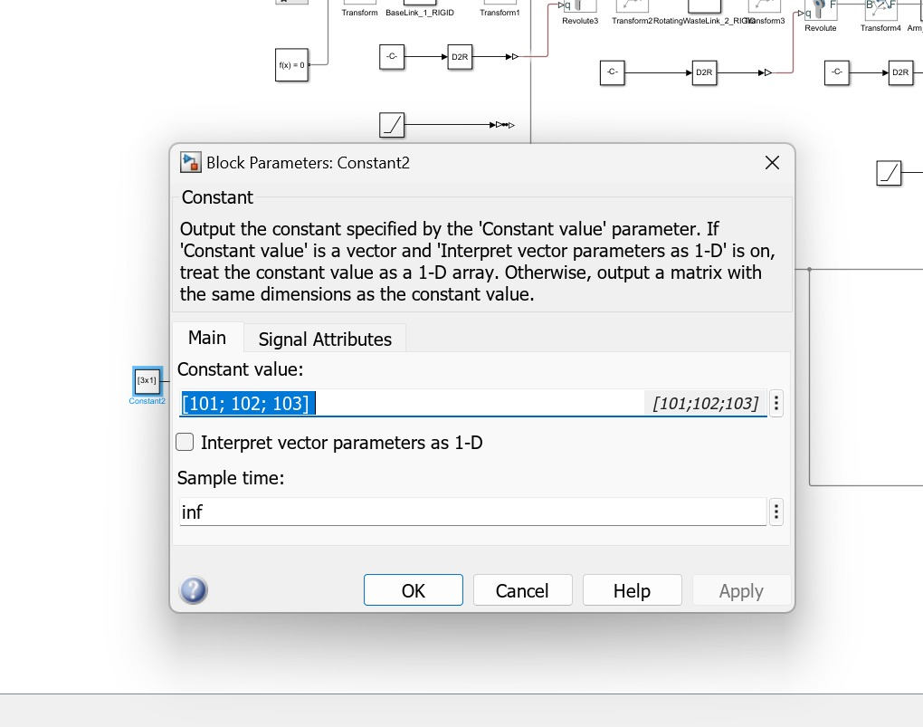

The output of the inverse position used as input for the forward position 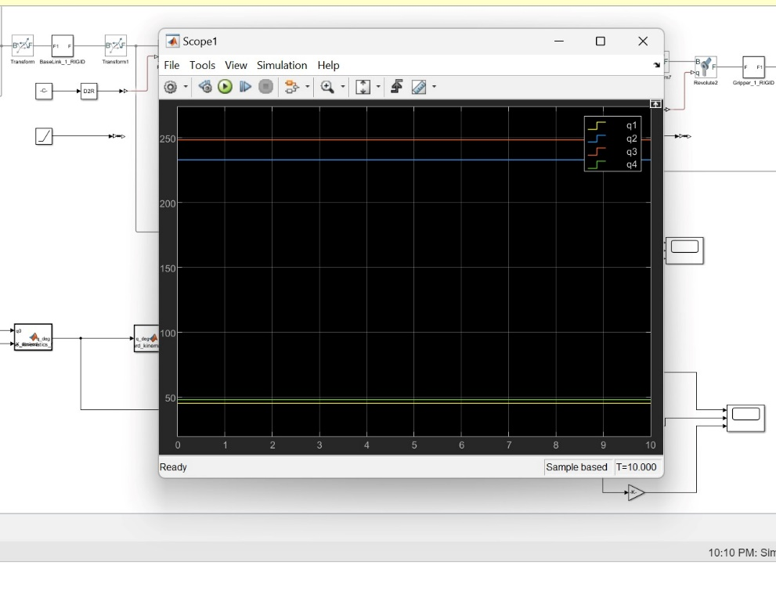
The output of forward position same as desired X
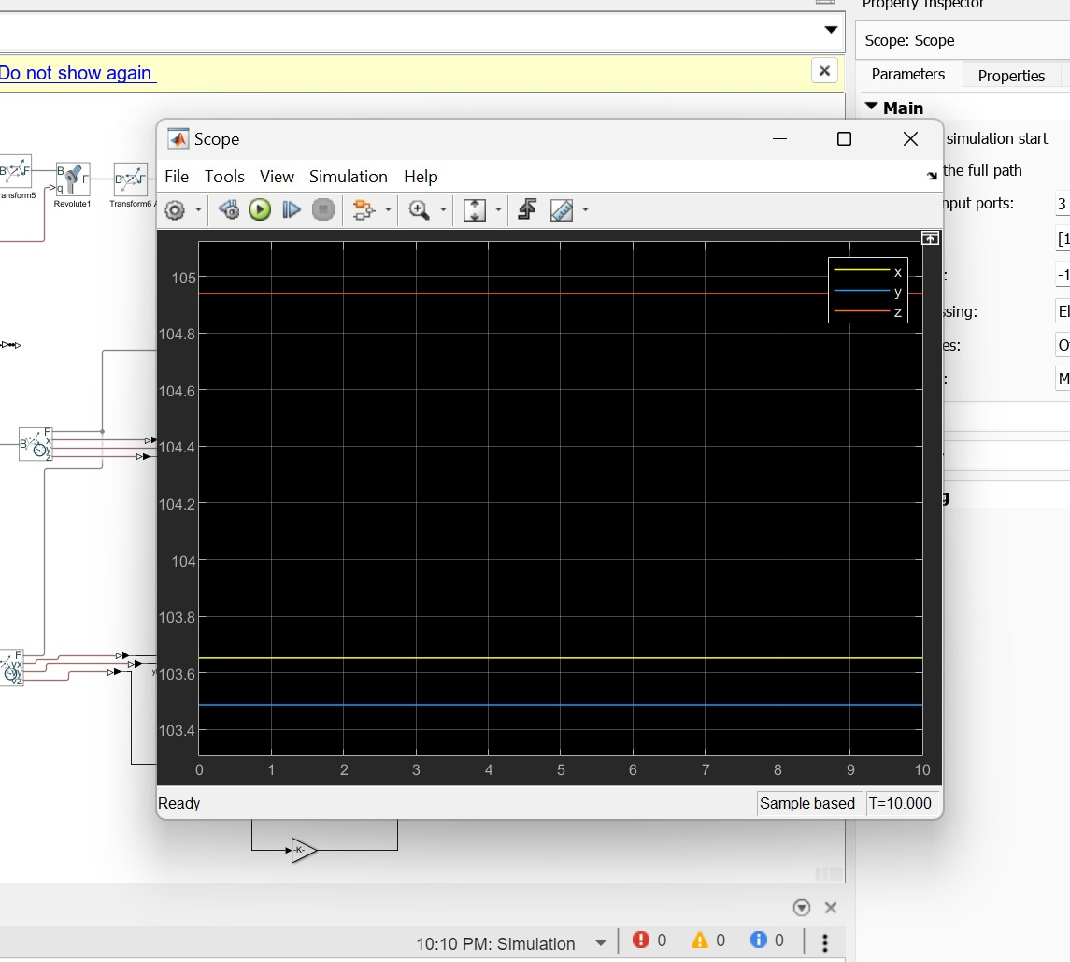

Also equal to output of simscape , small erroir due to different of lengths between matlab functions and simscape
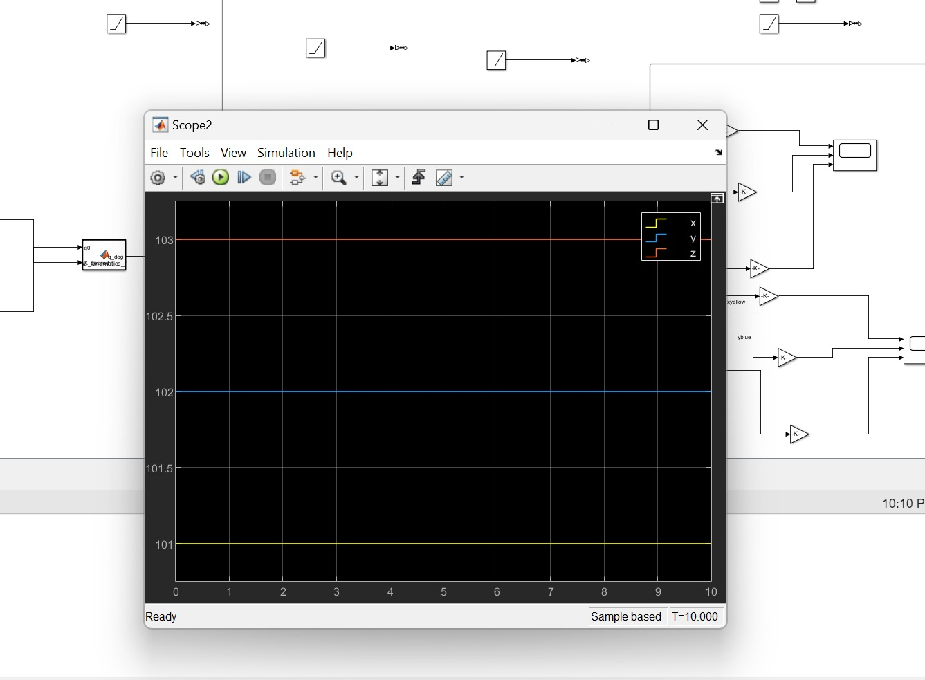

The view of simscape for position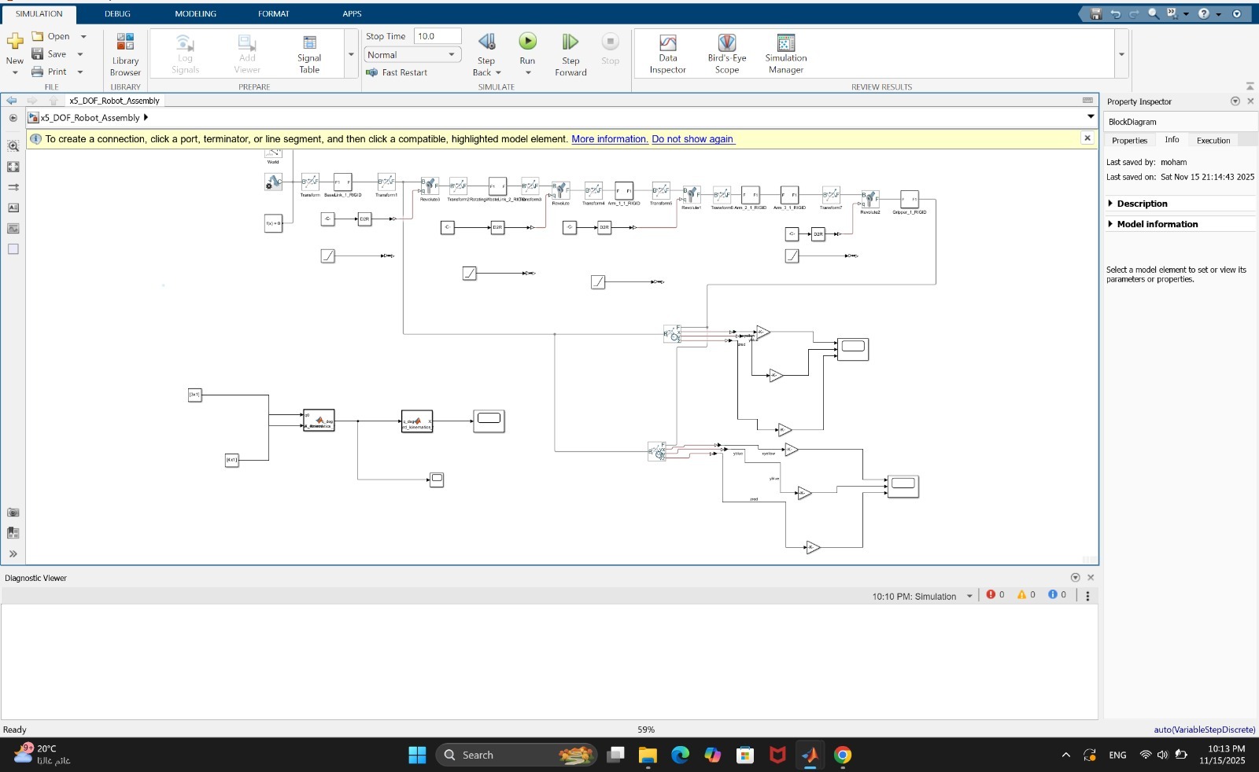

Simescape Velocity resaults:
Inputs for inverse velocity

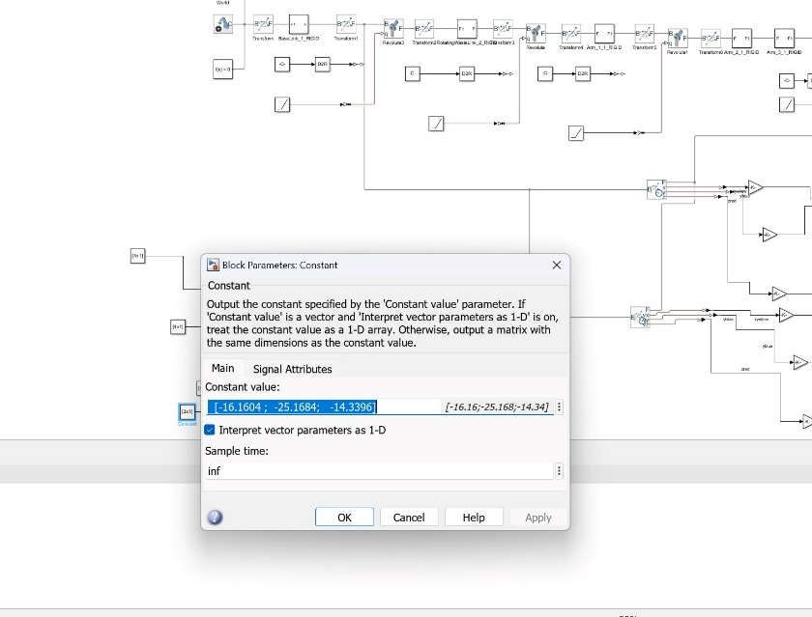

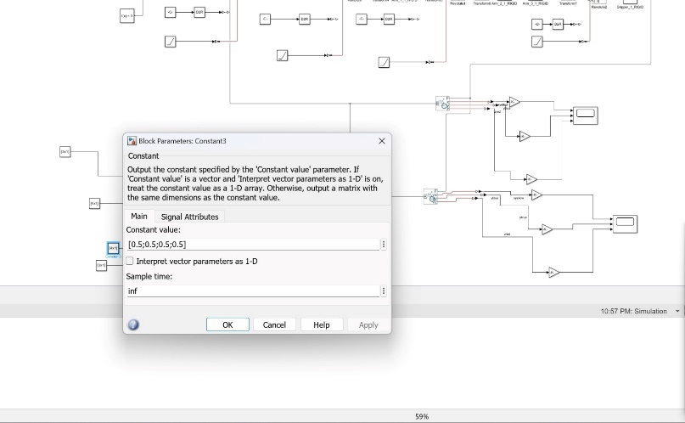

Output of inverse velocity which will be used as input for simscape and forward velocity
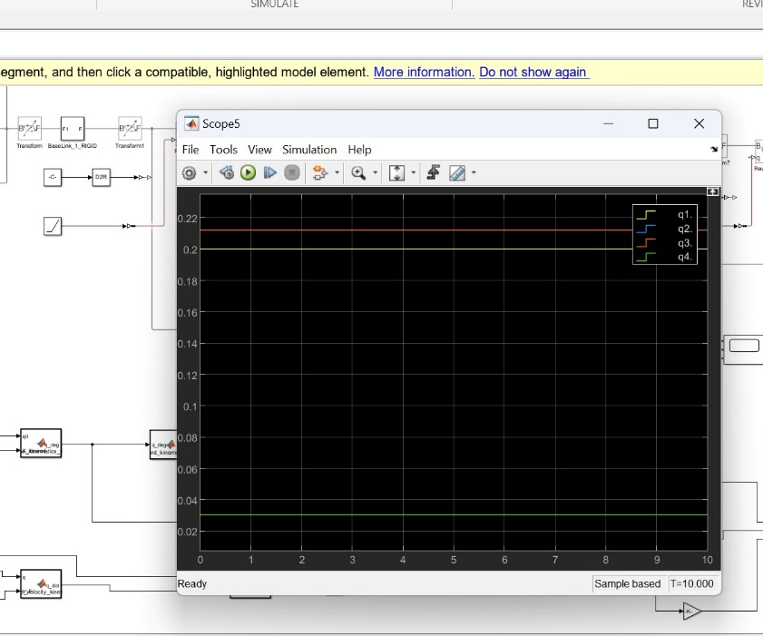

Output of matlab forward velocitys

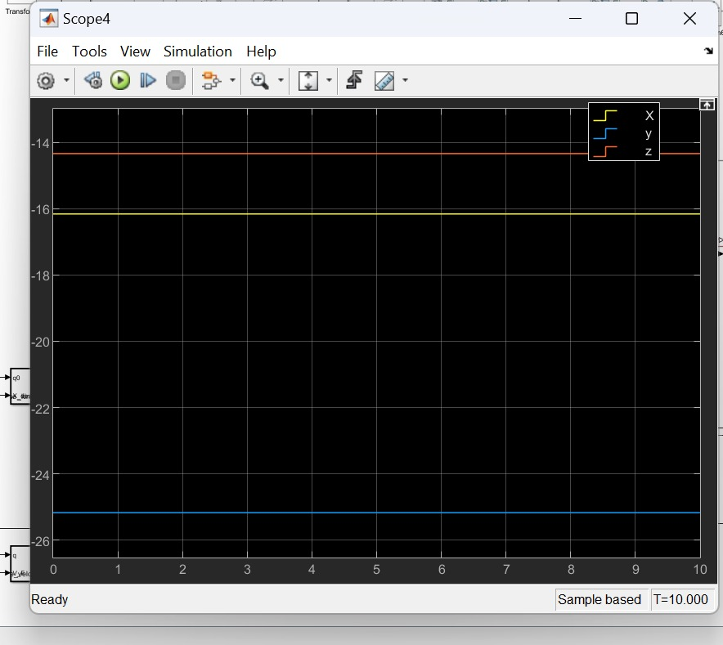

Output of simscaspe velocities same as desired at q =0.5 at T= 2.5 as qdot for all is 0.2 , so 0.2*2.5 = 0.5 .
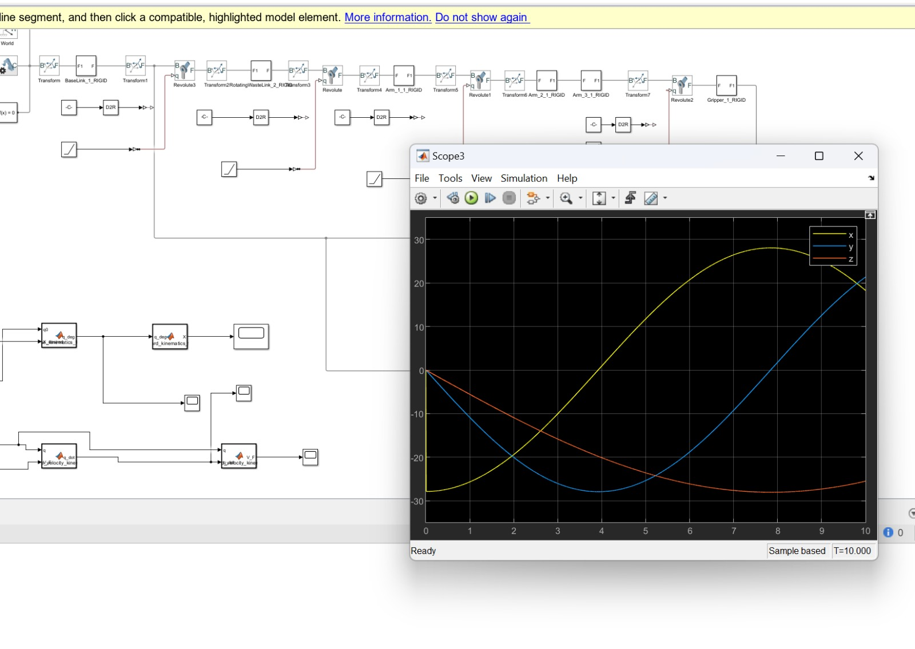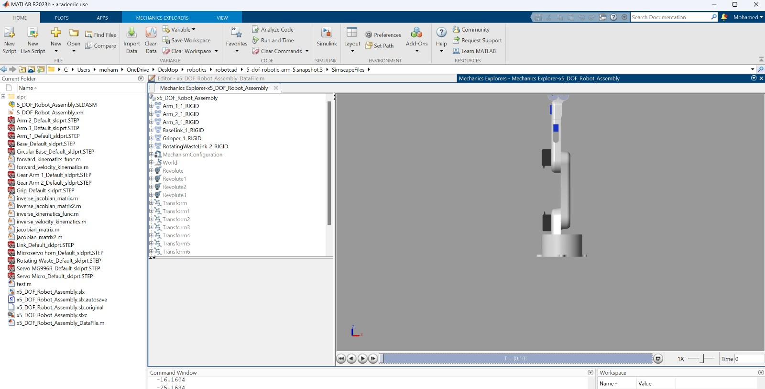

Simulink overview
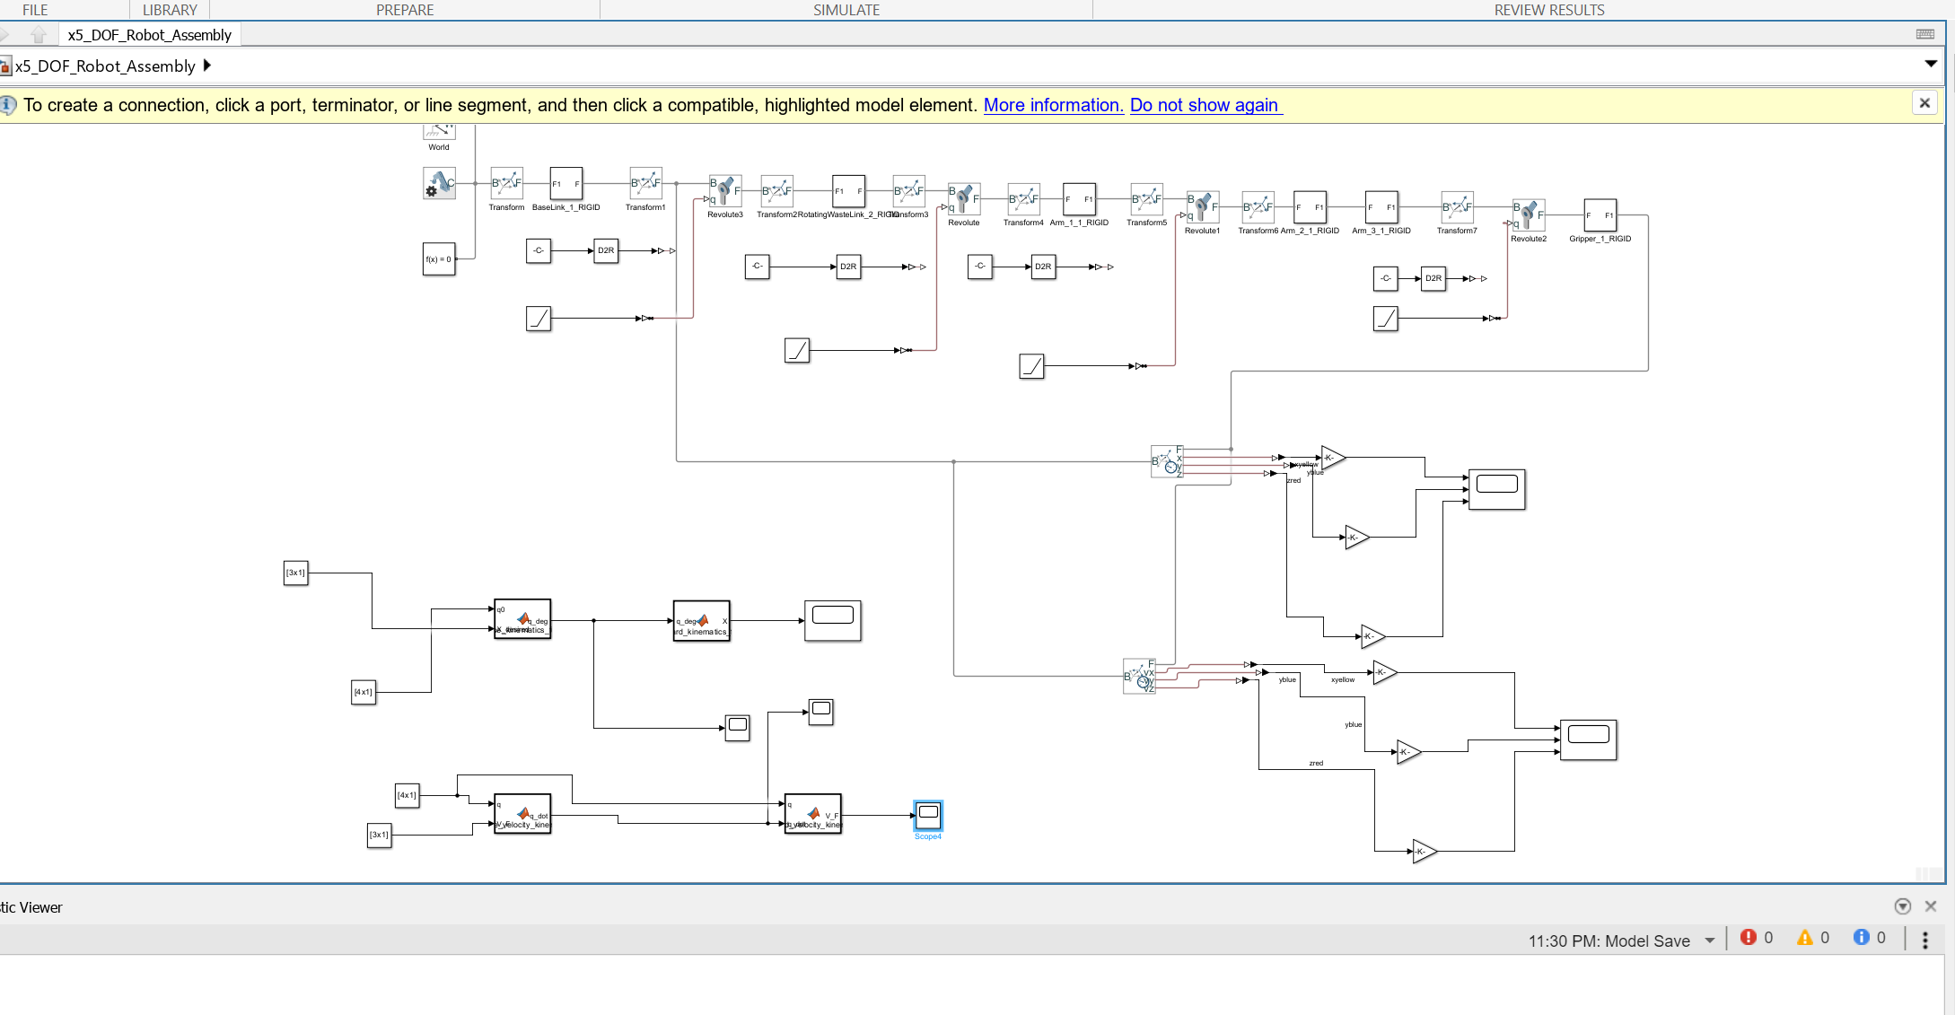

Case Studies for gazebos :

The first case study is for the inverse position kinematics were the inputs were as follows:
- q1, q2, q3=45
- q3=-45
- x1, z1=0.18
- y1=0

The second case study is for the forward velocity kinematics were the inputs were as follows:
- q1, q2, q4 =45
- q3= -45
- q1_dot, q2_dot, q3_dot, q4_dot = 10

The third case study is for the inverse velocity kinematics were the inputs were as follows:
- q1, q2, q4 =45
- q3= -45
- x_dot = 0.05
- y_dot, z_dot, w_x, w_y, w_z =0

All the case studies had similar outputs for both gazebo and python simulations.

Gazeebo Inverse Position resaults:

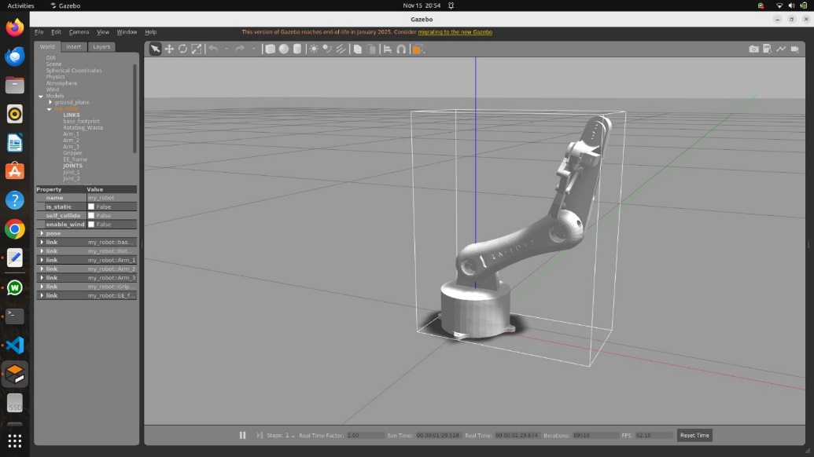
[INFO] [1763232966.999853, 157.420000]: [IK] Target Xd = [0.1800, 0.0000, 0.1800] m
Initial guess (deg) = [J1=-0.07, J2=-64.28, J3=-47.36, J5=249.49]
Solution (deg) = [J1=-0.07, J2=-64.28, J3=-47.36, J5=249.49]
Final error ||f|| = 4.018027e-04 m in 1 iterations.

Gazeebo forward velocity resaults:

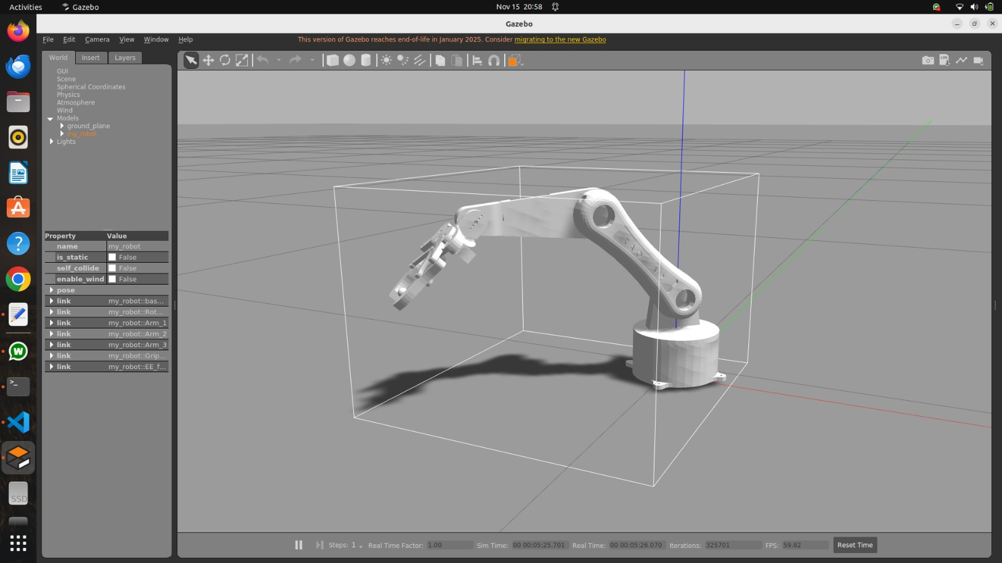

[INFO] [1763233172.378938, 362.616000]: [Vel-FK] q(deg) = [J1=45.00, J2=45.00, J3=-45.00, J5=45.00], qd(deg/s) = [J1d=10.00, J2d=10.00, J3d=10.00, J5d=10.00]
EE linear vel v = [0.0179, -0.0371, -0.0210] m/s
EE angular vel w = [0.1234, -0.1234, 0.1745] rad/s

Gazeebo inverse velocity resaults:

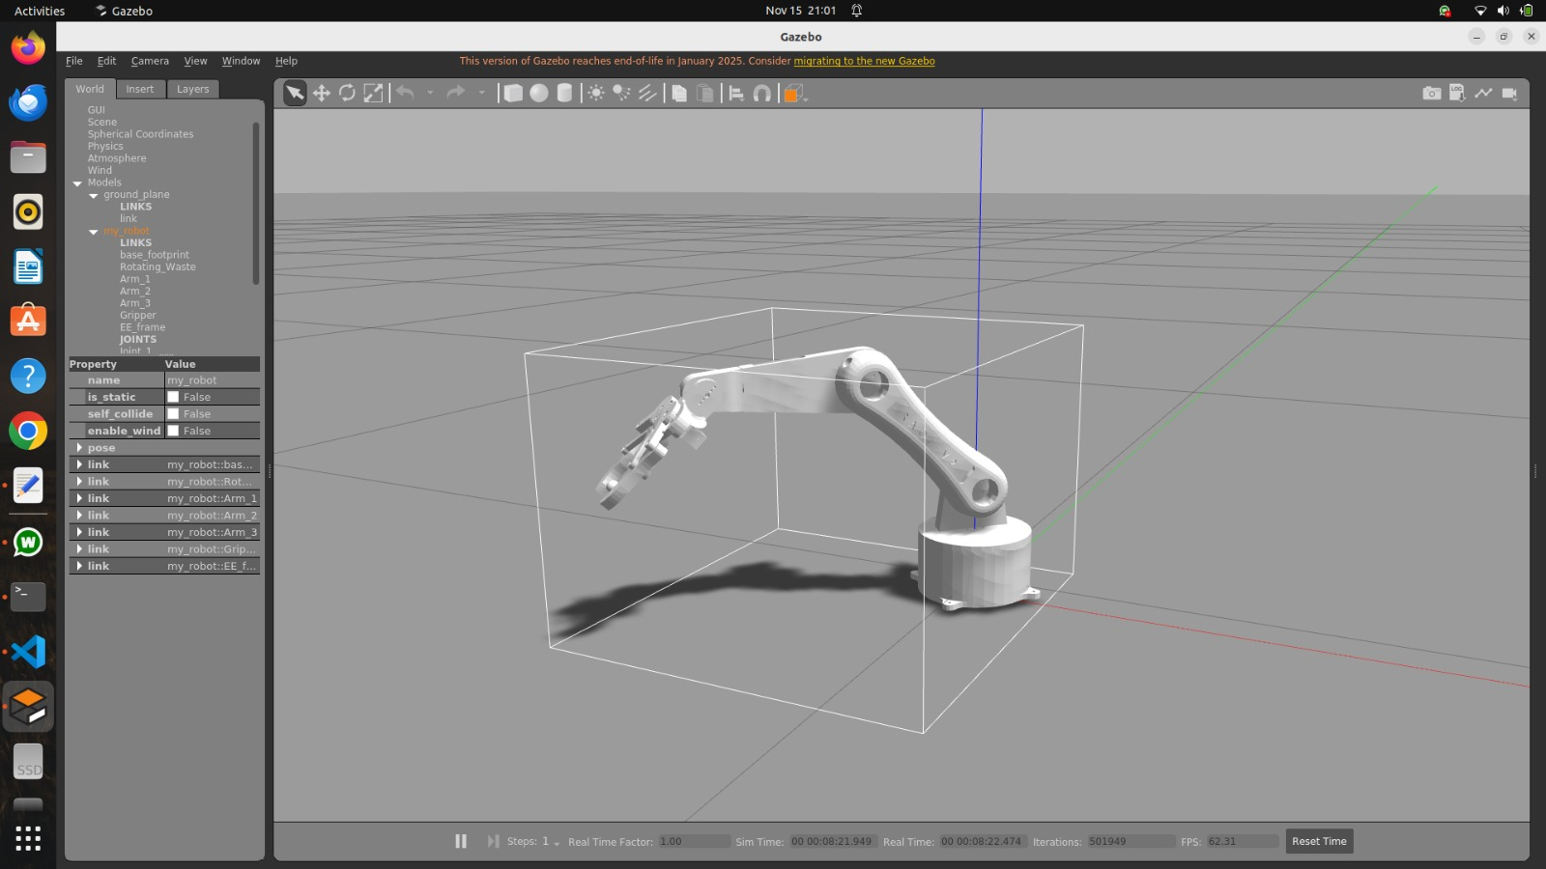

[INFO] [1763233333.088535, 523.181000]: [Vel-IK] q(deg) = [J1=45.00, J2=45.00, J3=-45.00, J5=45.00]
Xdot_des = v=[0.0500, 0.0000, 0.0000] m/s, w=[0.0000, 0.0000, 0.0000] rad/s
qdot_sol (deg/s) = [J1d=0.43, J2d=-20.46, J3d=-40.13, J5d=-19.67]

